Class Activity 3rd Aug 2026
1. ArithmeticException – Student Calculator
Problem Statement:
Develop a Java program to calculate the average marks of students. The program should
accept the total marks and the number of subjects from the user. If the number of subjects
entered is 0, the program should handle the exception gracefully and display an appropriate
error message instead of terminating abruptly.
Requirements:
• Read total marks and number of subjects.
• Calculate and display the average.
• Handle ArithmeticException using try-catch.
• Display a user-friendly error message when division by zero occurs.
CODE:
import java.util.Scanner;

public class StudentCalculator {
public static void main(String[] args) {
Scanner sc = new Scanner(System.in);

try {
System.out.print("Enter Total Marks: ");
int totalMarks = sc.nextInt();

System.out.print("Enter Number of Subjects: ");
int subjects = sc.nextInt();

int average = totalMarks / subjects;

System.out.println("Average Marks = " + average);
} catch (ArithmeticException e) {
System.out.println("Error: Number of subjects cannot be zero.");
}

sc.close();
}
}

OUTPUT:
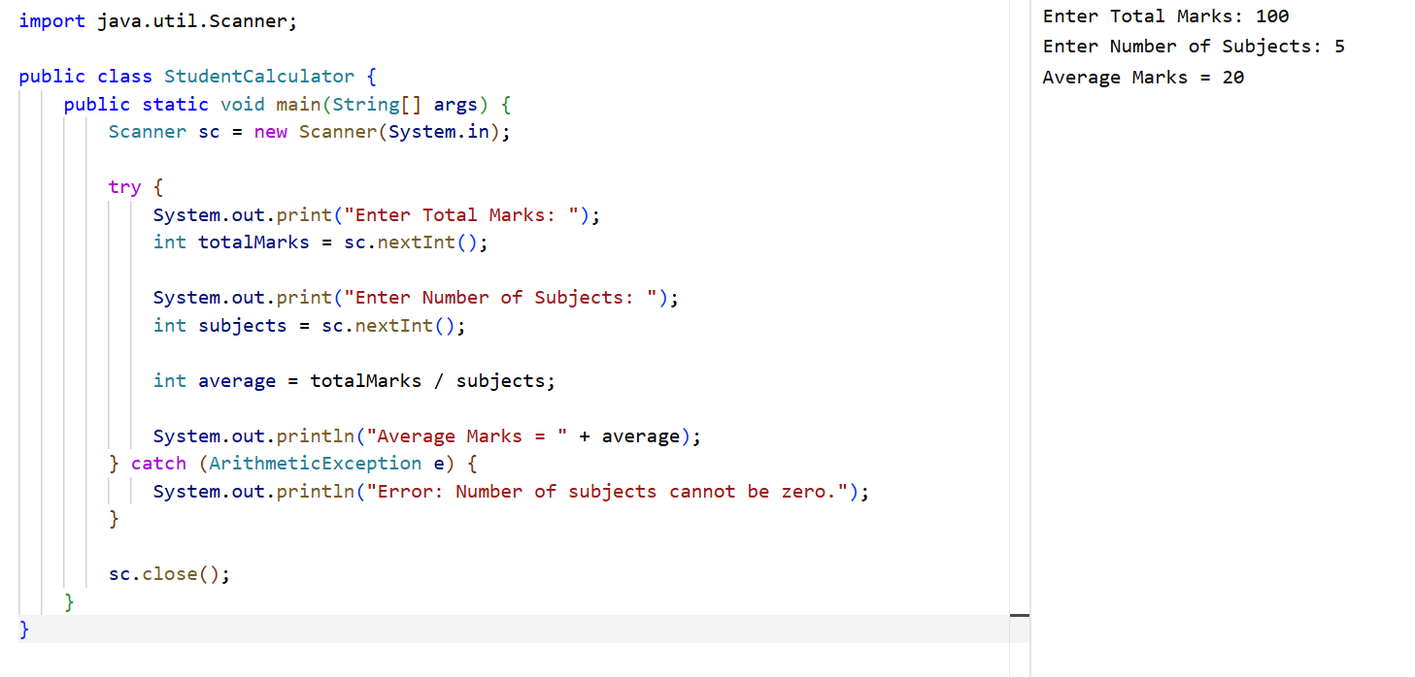

2. NullPointerException – Employee Management System
Problem Statement:
Develop a Java program for an Employee Management System. The program should create
an employee object and display the employee's name. Demonstrate a situation where the
employee object is not initialized (null) and handle the resulting exception gracefully.
Requirements:
• Create an Employee class with employee ID and name.
• Attempt to access the employee object's data without creating the object.
• Handle NullPointerException using try-catch.
• Display an appropriate message instead of allowing the program to crash.
CODE:
class Employee {
int empId;
String name;

Employee(int empId, String name) {
this.empId = empId;
this.name = name;
}
}

public class EmployeeManagement {
public static void main(String[] args) {

Employee emp = null;

try {
System.out.println("Employee Name: " + emp.name);
} catch (NullPointerException e) {
System.out.println("Error: Employee object is not initialized.");
}
}
}

OUTPUT:
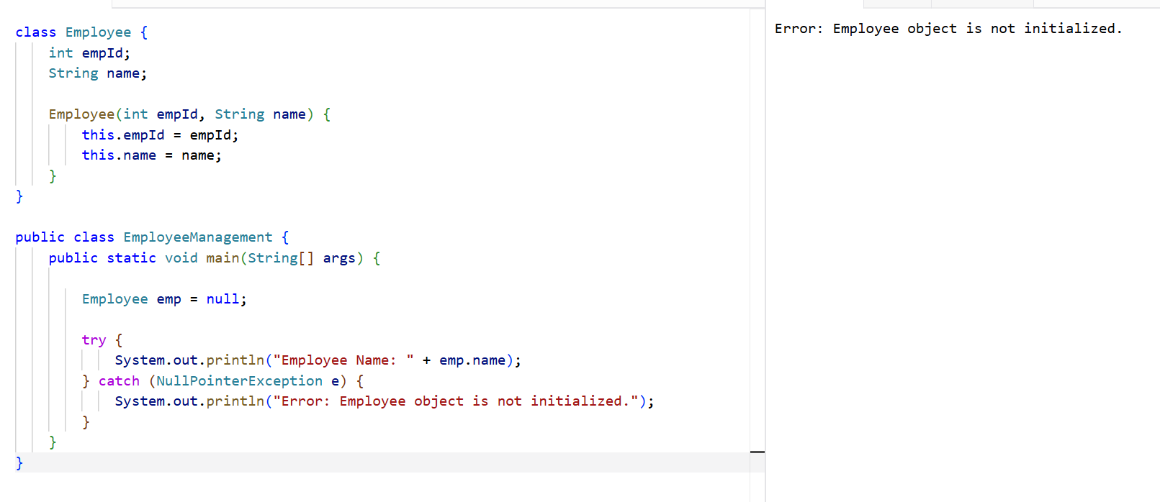

3. ArrayIndexOutOfBoundsException – Student Marks Processing
Problem Statement:
Develop a Java program to store the marks of five students in an array. Allow the user to
enter the index of the student whose mark should be displayed. If the entered index is outside
the valid range, handle the exception and display an informative message.
Requirements:
• Store marks in an integer array of size 5.
• Accept an index from the user.
• Display the mark corresponding to the entered index.
• Handle ArrayIndexOutOfBoundsException using try-catch.
• Inform the user about the valid index range.
CODE:
import java.util.Scanner;

public class StudentMarks {
public static void main(String[] args) {

Scanner sc = new Scanner(System.in);

int[] marks = {80, 85, 90, 75, 88};

try {
System.out.print("Enter student index (0-4): ");
int index = sc.nextInt();

System.out.println("Student Mark = " + marks[index]);
} catch (ArrayIndexOutOfBoundsException e) {
System.out.println("Error: Invalid index! Enter a value between 0 and 4.");
}

sc.close();
}
}
OUTPUT:
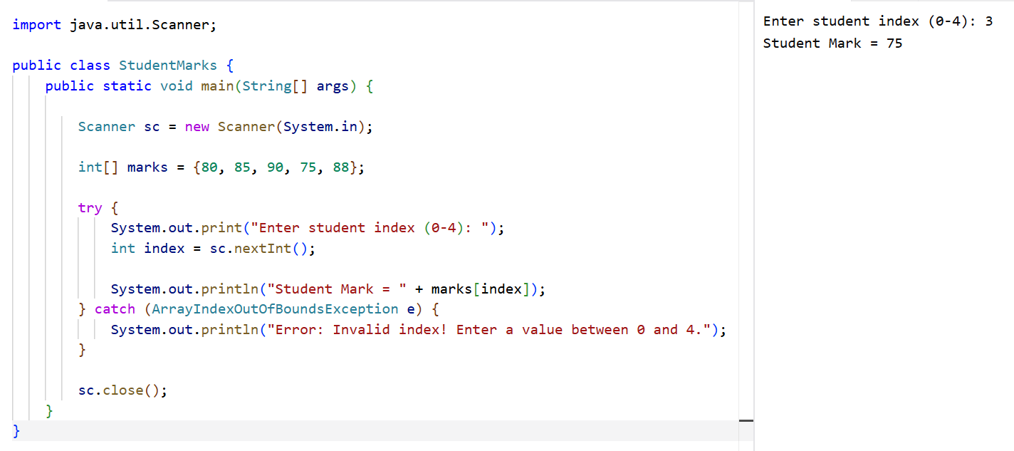

4. NumberFormatException – Customer Registration System
Problem Statement:
Develop a Java program for a Customer Registration System. The program should accept the
customer's age as a String and convert it into an integer. If the user enters invalid data (such
as alphabets or special characters), the program should handle the exception and display an
appropriate error message.
Requirements:
• Read age as a String.
• Convert the String into an integer using Integer.parseInt().
• Display the customer's age if the input is valid.
• Handle NumberFormatException using try-catch.
• Display a meaningful message when invalid input is entered.
CODE:
import java.util.Scanner;

public class CustomerRegistration {
public static void main(String[] args) {

Scanner sc = new Scanner(System.in);

try {
System.out.print("Enter Customer Age: ");
String age = sc.nextLine();

int customerAge = Integer.parseInt(age);

System.out.println("Customer Age = " + customerAge);
} catch (NumberFormatException e) {
System.out.println("Error: Please enter a valid numeric age.");
}

sc.close();
}
}
OUTPUT:
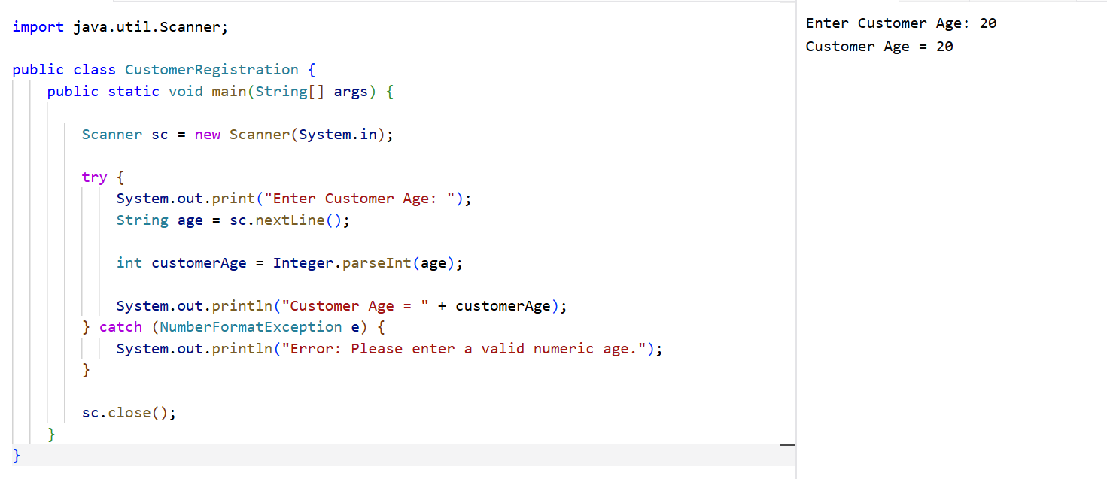
5.NULL POINTER EXCEPTION
CODE:
public class NullPointerDemo {
public static void main(String[] args) {

try {
String s = null;
System.out.println(s.length());
}
catch (NullPointerException e) {
System.out.println("NullPointerException Occurred!");
System.out.println("String object is null.");
}

}
}
OUTPUT:
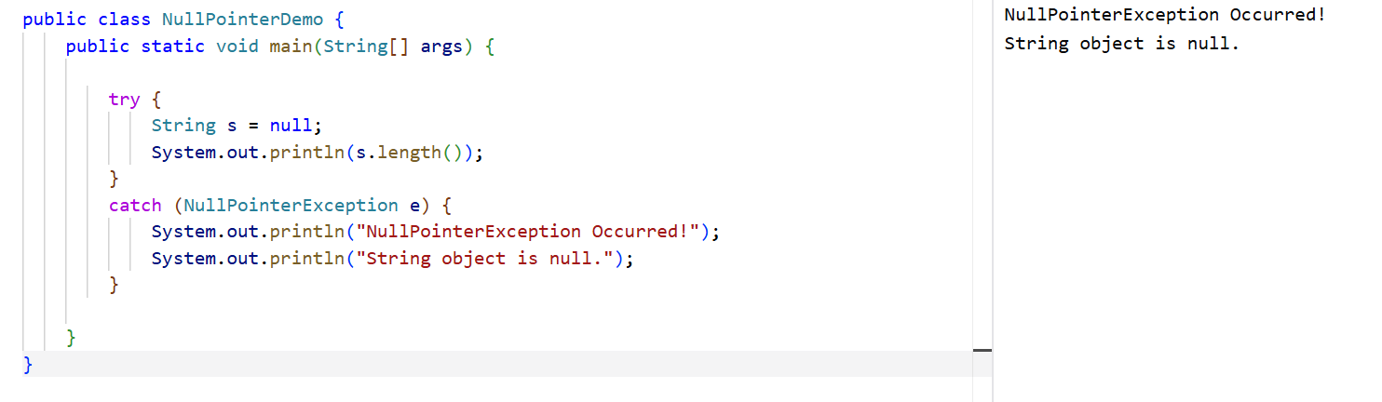

6.NUMBER FORMAT EXCEPTION
CODE:
public class NumberFormatDemo {
public static void main(String[] args) {

try {
String s = "abc";
int i = Integer.parseInt(s);
System.out.println(i);
}
catch (NumberFormatException e) {
System.out.println("NumberFormatException Occurred!");
System.out.println("Invalid number format.");
}

}
}
OUTPUT:

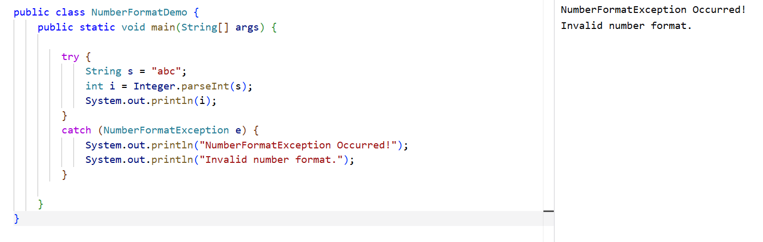

7. ArrayIndexOutOfBoundsException
CODE:
public class ArrayIndexDemo {
public static void main(String[] args) {

try {
int a[] = new int[5];
a[10] = 50;
}
catch (ArrayIndexOutOfBoundsException e) {
System.out.println("ArrayIndexOutOfBoundsException Occurred!");
System.out.println("Array index is out of range.");
}

}
}
OUTPUT:
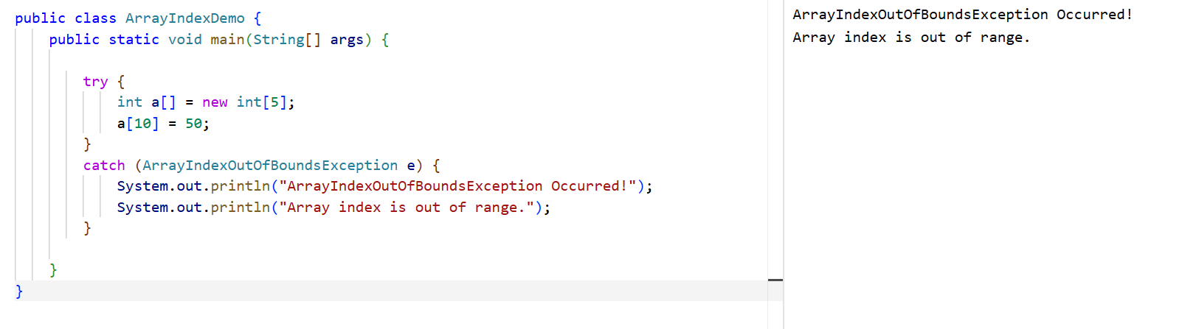

8.ARITHEMETIC EXCEPTION
CODE:
public class ArithmeticExceptionDemo {
public static void main(String[] args) {

try {
int num1 = 30;
int num2 = 0;

int output = num1 / num2;

System.out.println("Result = " + output);
}
catch (ArithmeticException e) {
System.out.println("ArithmeticException Occurred!");
System.out.println("You can't divide an integer by 0.");
}

}
}
OUTPUT:
